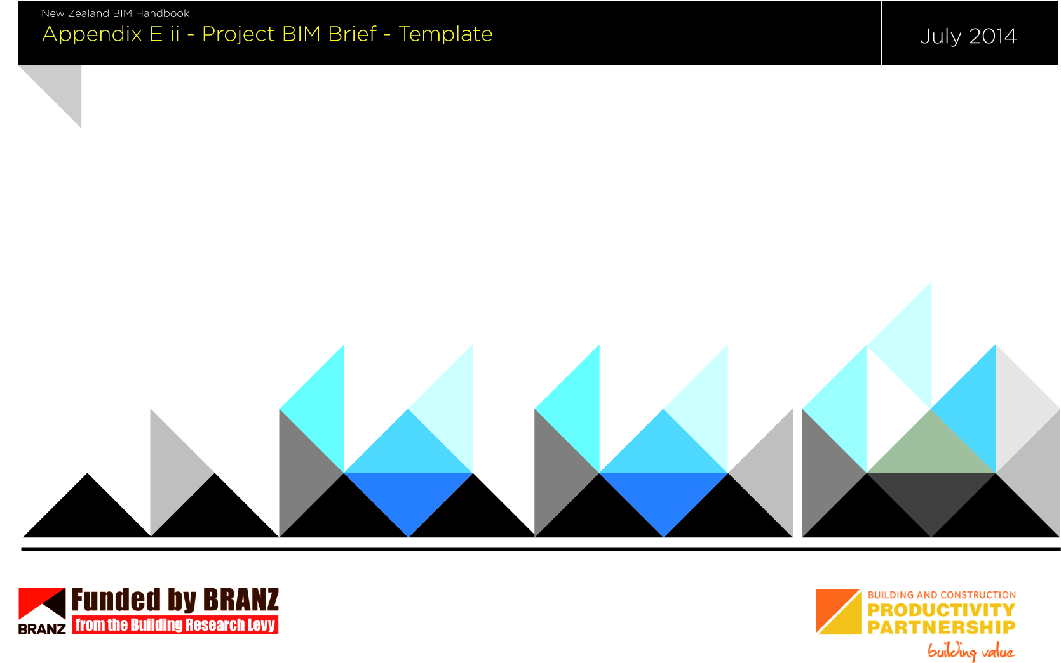
Client project goals
BIM Uses
BIM capability required
The Project BIM Brief (PBB) is a document that defines the client requirements and expectations for a project with regard to BIM.

The document identifies goals, objectives, and people’s responsibilities.

The Project BIM Brief should be developed in the pre-design phase to be fully effective in relation to BIM. It is a briefing document in its own right and could form part of a Request for Proposal (RFP).

Post this phase the BIM Execution Plan will form the framework of the management and operational functions of BIM throughout the project’s life cycle.

This Project BIM Brief template can be used as a starting point for BIM enabled projects, in conjunction with the Project BIM Brief example provided in Appendix E i.

The Project BIM Brief should be developed with reference to the New Zealand BIM Handbook.

CONTENTS
CONTENTS 3
PROJECT INFORMATION 4
PROJECT SCHEDULE 4
KEY PROJECT CONTACTS 5
PROJECT GOALS 5
BIM USE COMPETENCY REQUIREMENTS 6
CLIENT SPECIFIC REQUIREMENTS 6
PROJECT DELIVERABLES 7
REFERENCE DOCUMENTS & STANDARDS 7

PREPARED BY: | COMPANY: | DATE:
Name | Name | 1/1/2014

REVISION RECORD
REVISION | DATE | BY WHOM | COMMENTS

PROJECT INFORMATION

Project name:
Project owner:
Project address/location
Brief project description:
Contract type/delivery method:
Contractor engagement - indicative date:

PROJECT SCHEDULE
Fill in the table below with any major project milestones which occur during the project life cycle.
Project phase/milestone | Estimated start date | Estimated completion date
Pre-design
Concept design
Preliminary design
Developed design
Detailed design
Construction
Handover
Operation

KEY PROJECT CONTACTS
List all the known key stakeholders who will be involved in BIM on this project.
Role | Discipline | Company name | Contact name | Contact details
Client representative | NA
Project manager | NA
BIM manager(s) | NA
Lead consultant
Other project roles
PROJECT GOALS

List client goals and expectations for the project. This table will assist to define BIM uses required for the project in alignment with the project goals.
Refer to Appendix D for BIM uses.

Priority  (high/med/low) | Goal description - value added objectives | BIM Uses

BIM USE COMPETENCY REQUIREMENTS
The purpose of this table is to identify the potential value, experience and competencies required of responsible parties for the BIM enablement of the project.

BIM Use | Value to project | Responsible parties | Value to responsible parties | Competencies required to implement
 | High/med/low |  | High/med/low

CLIENT SPECIFIC REQUIREMENTS
List any client-specific requirements including any standards or protocols that might create a different work flow for the project team.

Specific requirements

PROJECT DELIVERABLES
In this section, list the BIM deliverables for the project and the format in which the information will be delivered.

BIM Use | Approximate due date/stage | Format | Comments

REFERENCE DOCUMENTS & STANDARDS
The following documents are listed for reference.

Generic title | Applicable reference document/notes | Version



